Q1. Load the given retail sales dataset into a Pandas DataFrame and display the first 5 rows along with the dataset information to understand its structure
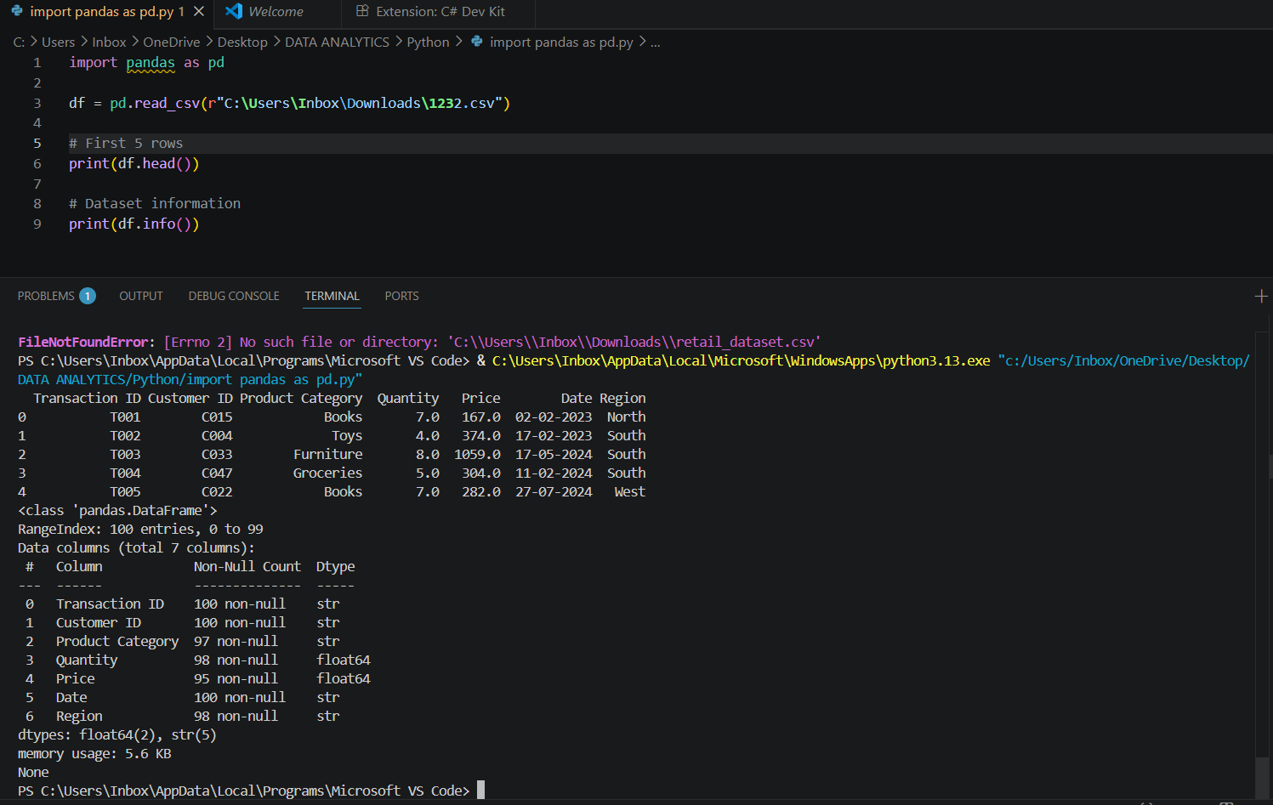
Q2. Inspect the dataset and identify missing values in each column. Display the total number of missing values present in the dataset.
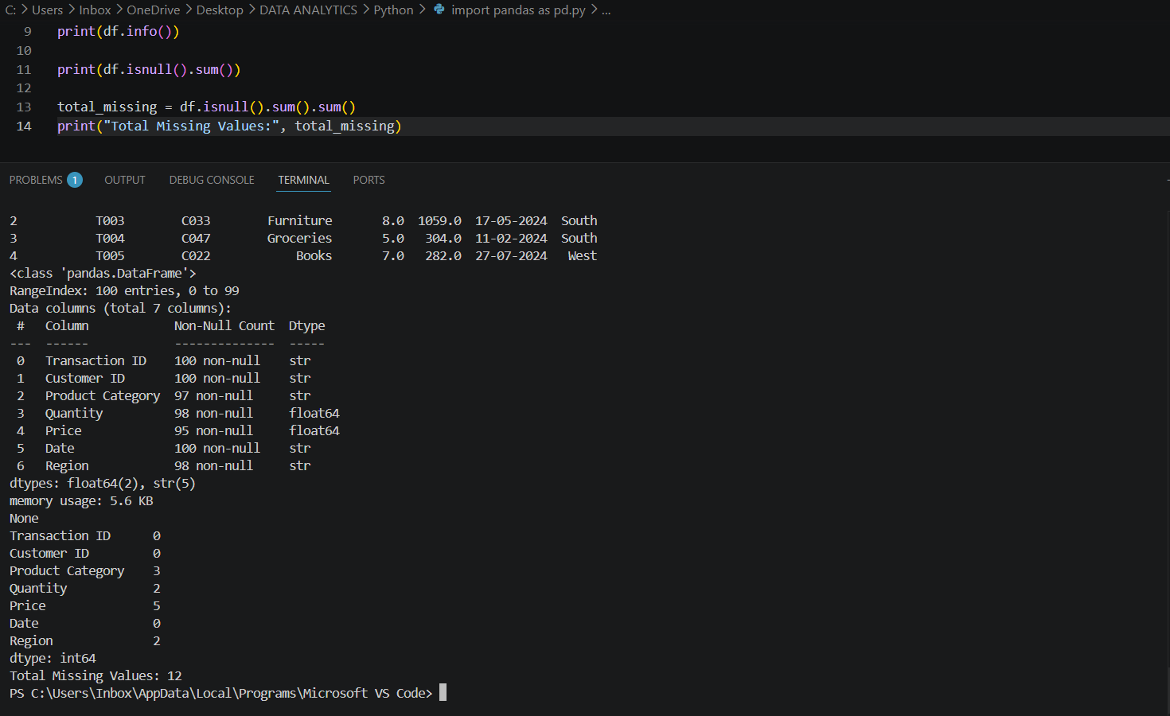

Q3. Replace missing values in the Quantity and Price columns with their respective mean values using Pandas.
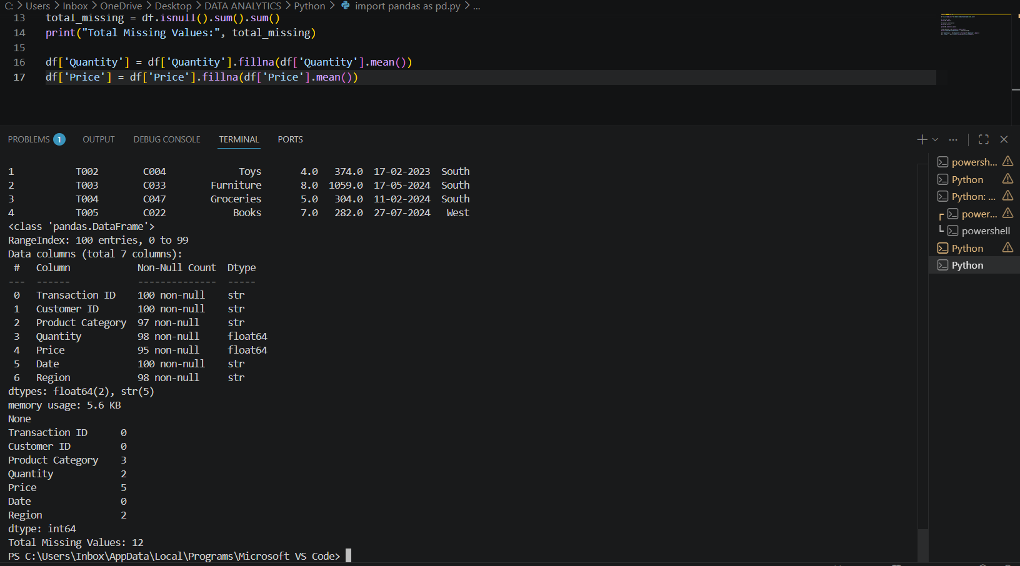
Q4. Remove all rows where the Product Category or Region column contains missing values.
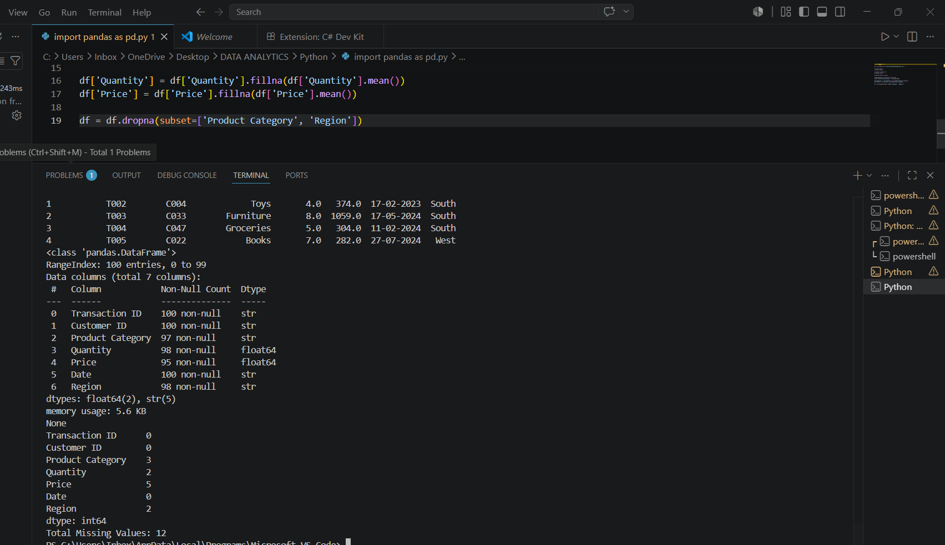

Q5. Create a new column called Revenue using NumPy, where: Revenue = Quantity × Price Display the updated dataset with the new column.
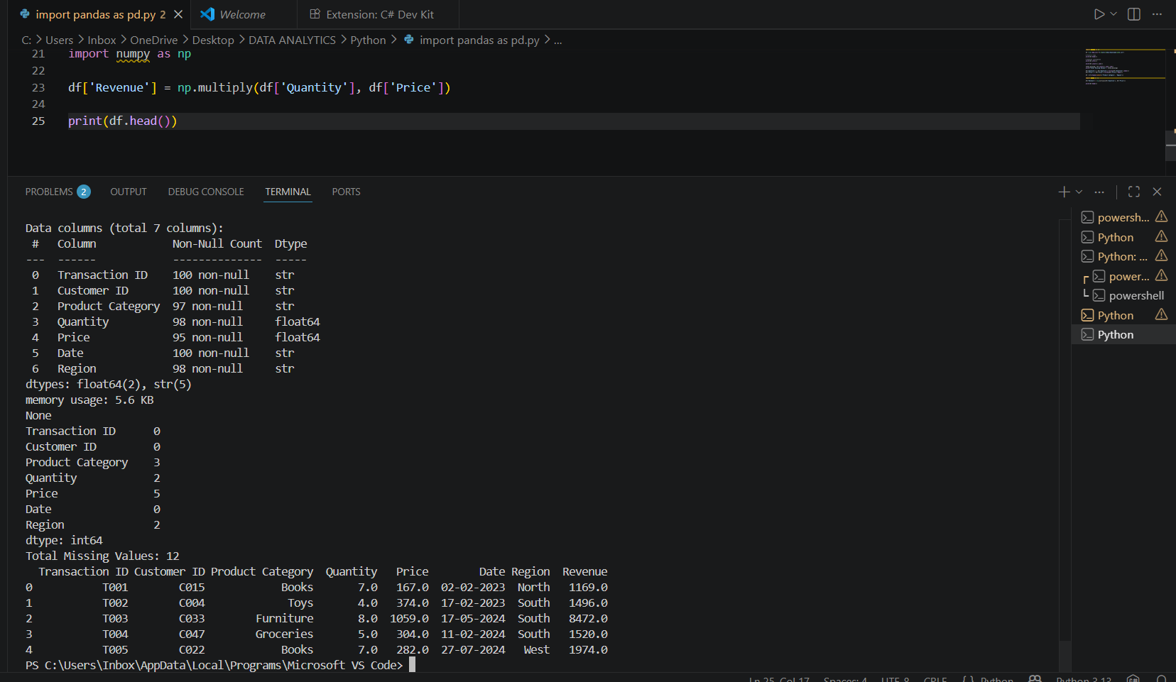

Q6. Using NumPy, calculate the total revenue generated from all transactions in the dataset.
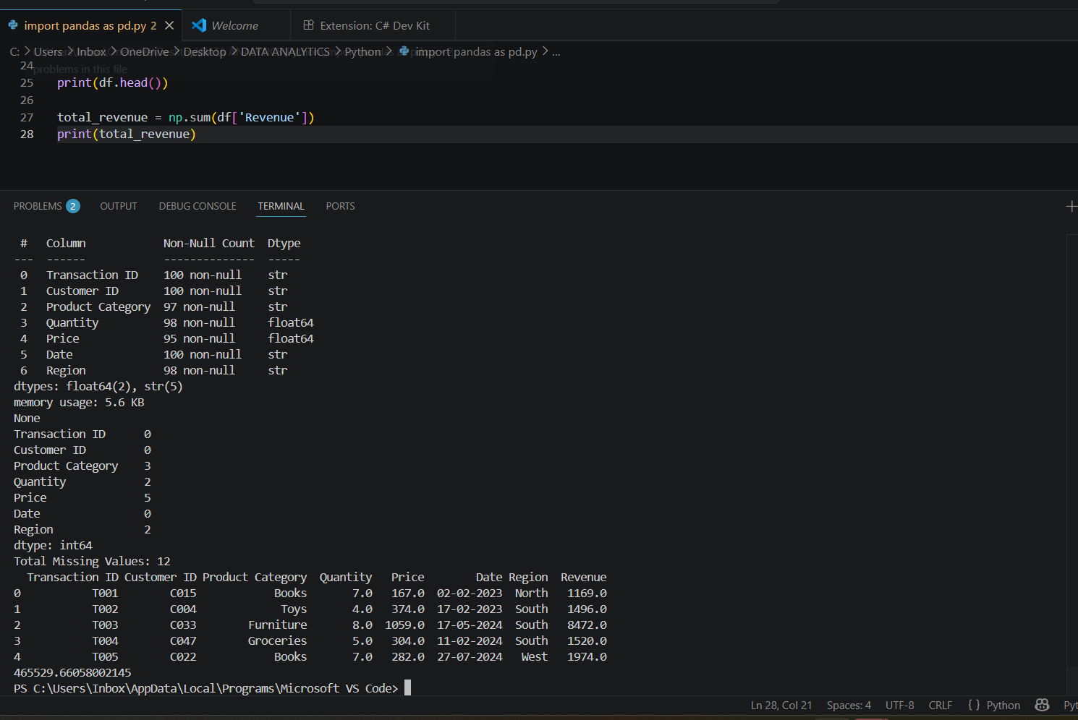

Q7. Group the dataset by Product Category and calculate the total revenue generated by each category.
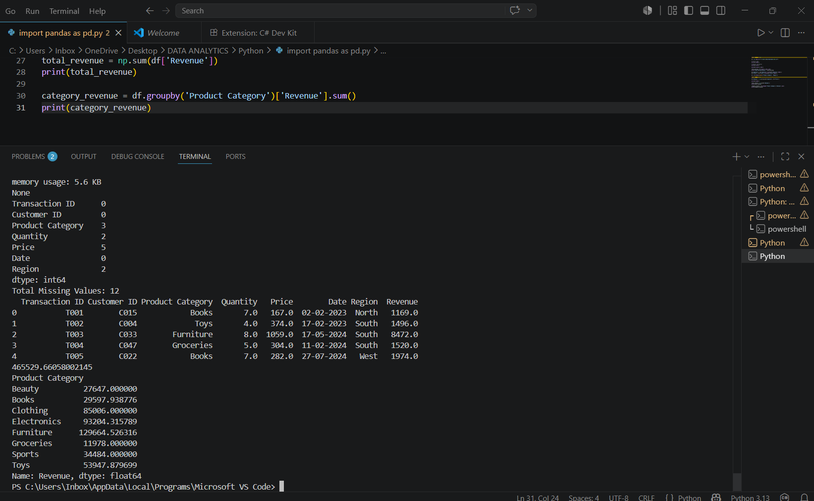

Q8. Based on the revenue calculated for each product category, identify the top 3 categories with the highest revenue and the bottom 3 categories with the lowest revenue.
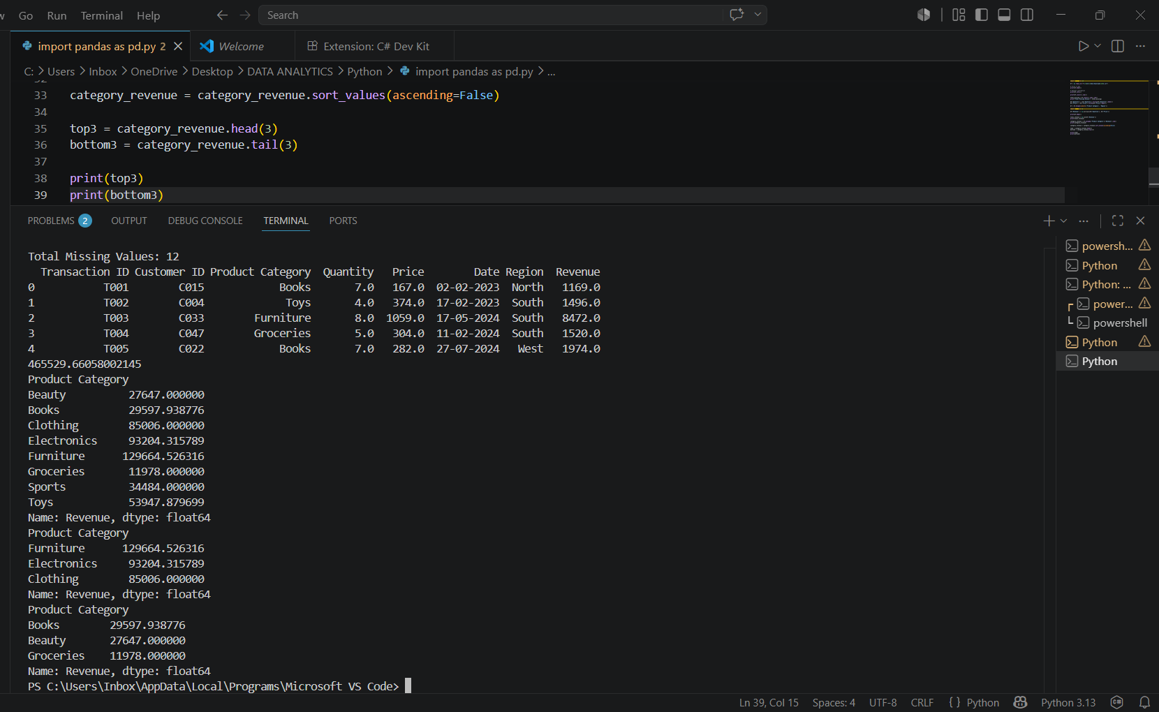

Q9. Group the dataset by Region and calculate the total revenue generated in each region. Identify the region with the highest revenue and the region with the lowest revenue.
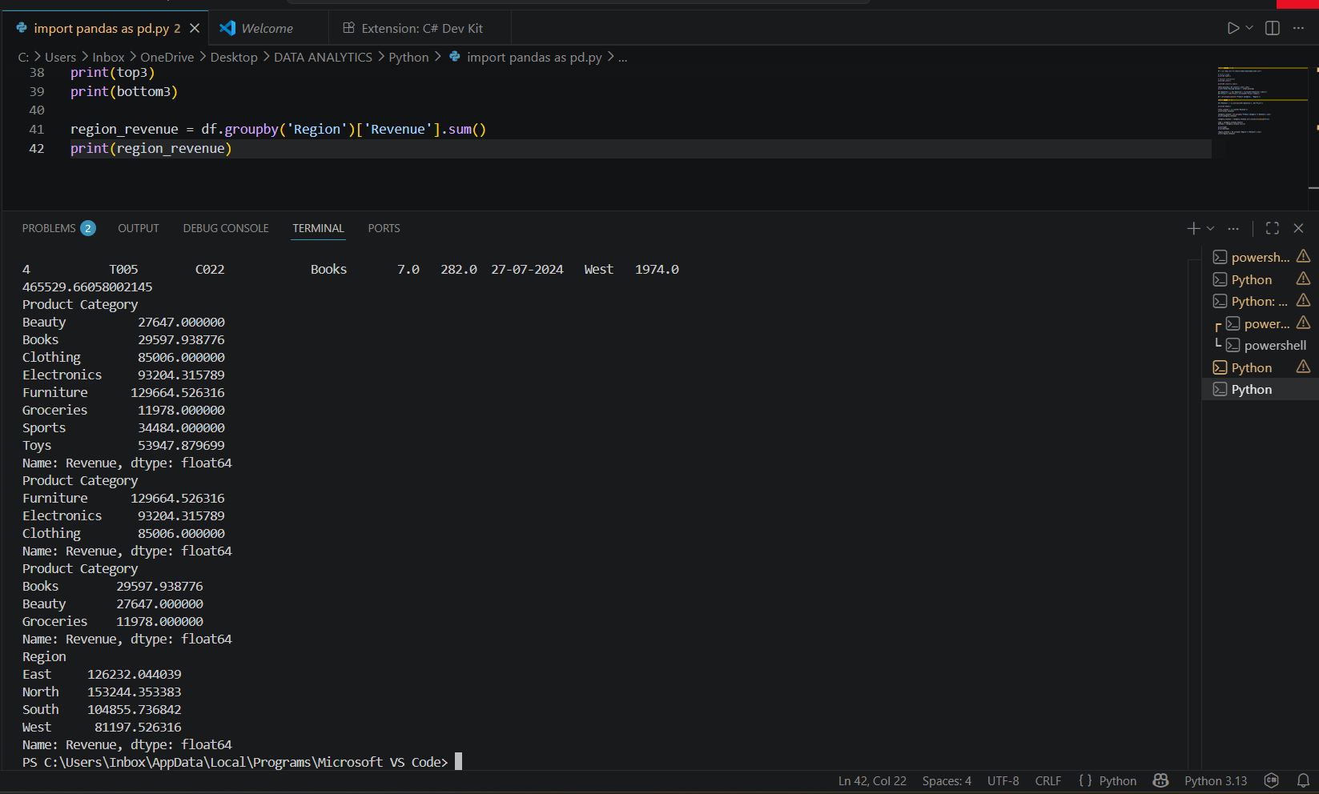

Q10. Extract the month from the Date column using Pandas and group the dataset by month to calculate the total monthly revenue. Also, calculate the mean, median, and standard deviation of the Revenue column using NumPy

